Updated 2017

Willow Tree Public School
Enrolment Policy
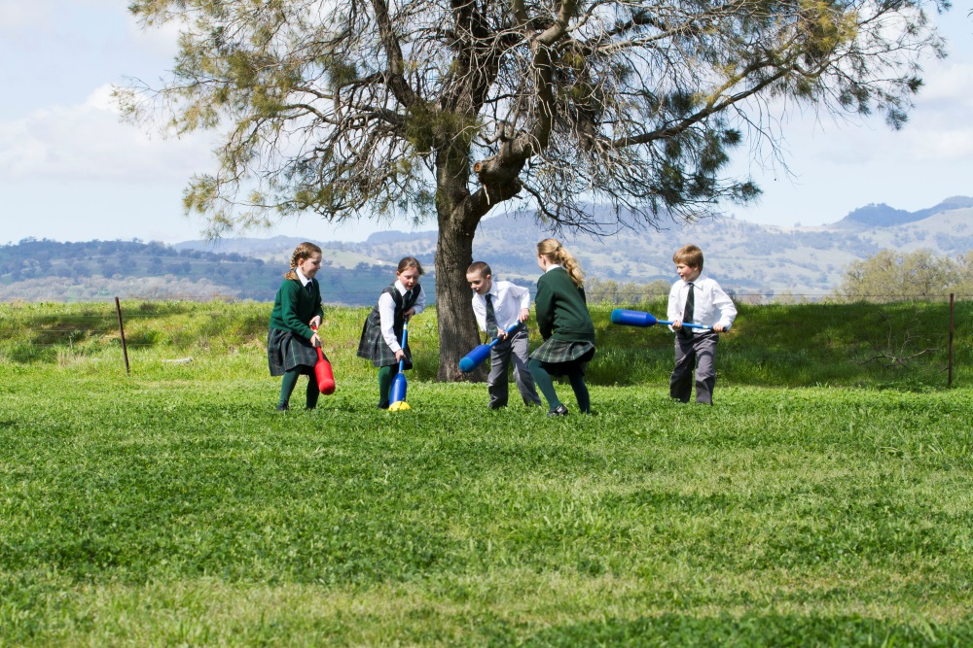
School Guidelines and Support Documentation for Implementation of NSW DoE Policy
Creation Date: July 2017
Last Update: July 2018
Review Date: July 2019
Willow Tree Public School 46 Merriwa Rd, Willow Tree NSW 2339 Phone: (02) 6747 1371
Fax: (02) 6747 1210 willowtree-p.school@det.nsw.edu.au

Implementing NSW Department of Education (DoE) Enrolment of Students in Government Schools Policy at Willow Tree Public School

Rationale: Willow Tree Public School is committed to ensuring compliance with NSW Department of Education Policies. This policy provides information for the community and direction for school personnel on the entitlements, requirements and procedures for the enrolment of students at Willow Tree Public School.

Current Department of Education Policy

Enrolment of Students in NSW Government Schools: A Summary and Consolidation of Policy (see attached).

General Principles Governing Enrolment
- A student is considered to be enrolled when an Application for Enrolment has been received, reviewed and accepted by the school principal.
- A student should be enrolled in one school only at any given time.
- Children are entitled to be enrolled at the government school that is designated for the intake area within which the child’s home is situated and that the child is eligible to attend.
- Parents may seek to enrol their child in the school of their choice.
- School local areas are determined by the Department of Education through a process involving consultation with relevant parties.
- Schools are required to set an enrolment number to cater for anticipated local demand and to seek to ensure that every eligible local child has a place at his or her local school if he or she chooses to attend it.
- Schools are required to have a written policy which states the grounds on which non-local enrolments will be accepted.
- The primary criteria for acceptance of non-local enrolments will include the availability of appropriate staff and permanent classroom accommodation.
- The policy and criteria should be expressed in plain English, and in community languages where necessary. It should be made clear what consideration will be given to each of the criteria.

Discrimination in Enrolment
No person will be discriminated against in enrolment on the grounds of their sex, age, race, religion, ethnicity, disability or sexual preference.

Enrolment Ceiling
Permanent Teaching Spaces x Capacity = School Enrolment Ceiling
Willow Tree Public School has 5 permanent teaching spaces available

DESCRIPTION | NUMBER | CAPACITY | TOTAL
Kindergarten | 1 | 20 | 20
Year 1 | 1 | 22 | 22
Year 2 | 1 | 25 | 25
Years 3-6 | 2 | 30 | 60
TOTAL | 5 | - | 127

(Based on permanent accommodation of 5 classroom buildings) – Enrolment Ceiling = 127

Enrolment Buffer
When consulting this enrolment buffer, please also read carefully information pertaining to non-local applications and impact on staffing. (Criteria for Consideration of Non-Local Enrolment Applications).

DESCRIPTION | NUMBER | CAPACITY | TOTAL | BUFFER | ACTUAL (or anticipated) | Available for non-local
Kindergarten | 1 | 20 | 20 | 2 | 13 | 5
Year 1 | 1 | 22 | 22 | 2 | 3 | 17
Year 2 | 1 | 25 | 25 | 3 | 10 | 12
Years 3-6 | 2 | 30 | 60 | 6 | 22 | 32

Processing Enrolment Applications
The receipt of an Application for Enrolment does not necessarily lead to an immediate enrolment and attendance at school. In order to facilitate the smooth transition of a new student, the principal will seek information from the student’s previous school and assess risk to students/staff, school routine and organisation.

Placement Panel
Where enrolment demand for non-local places exceeds availability, the school will establish a placement panel to consider all non-local enrolment applications. The panel will comprise of the principal, a staff representative and a school community member (nominated by the P&C). The placement panel will be chaired by the school principal who will have a casting vote if necessary.

Non-local Enrolment Applications
Students who reside outside the Willow Tree local area can make an Application for Enrolment at the school.
All non-local applications will be considered by the principal and where appropriate the school enrolment Placement Panel. The Placement Panel will consider the information provided in writing on the application, advise and make recommendations to the principal.

Note: The decision regarding whether a non-local student may be enrolled is initially made within the context of the school enrolment ceiling and buffer.

Criteria for Consideration of Non-Local Enrolment Applications
- Siblings already enrolled at the school.
- Safety and supervision of the student (access to before & after school care).
- Proximity and access to the school – where parents work in the area and/or the local school is not a viable alternative/option.
- Medical reasons.
- Compassionate Circumstances.
- Student has attended on-site community pre-school and participated in Willow Tree Public School transition program.

Application for Enrolment may be declined if placement generates demand for extra staff or creates disruption to school routine and organisation.

Feedback
Parents will be provided with an explanation of the decision of the principal or the placement panel (if necessary).

Waiting Lists and Appeals for Non-Local Applications
Where necessary the principal will establish a waiting list for non-local students. The parents of students placed on a waiting list will be advised in writing. This written information should include details relating to a student’s position on the list and an estimate of likely vacancies.

Consistent with DoE Policy, parents may appeal the decision of the placement panel to not offer a student a non-local enrolment. Appeals initially, should be made in writing to the principal. If this appeal is not resolved at the local level, the Director (Wollemi Network) will consider the appeal and make a determination.

John Ireland
Principal
Willow Tree Public School
21 July 2017

